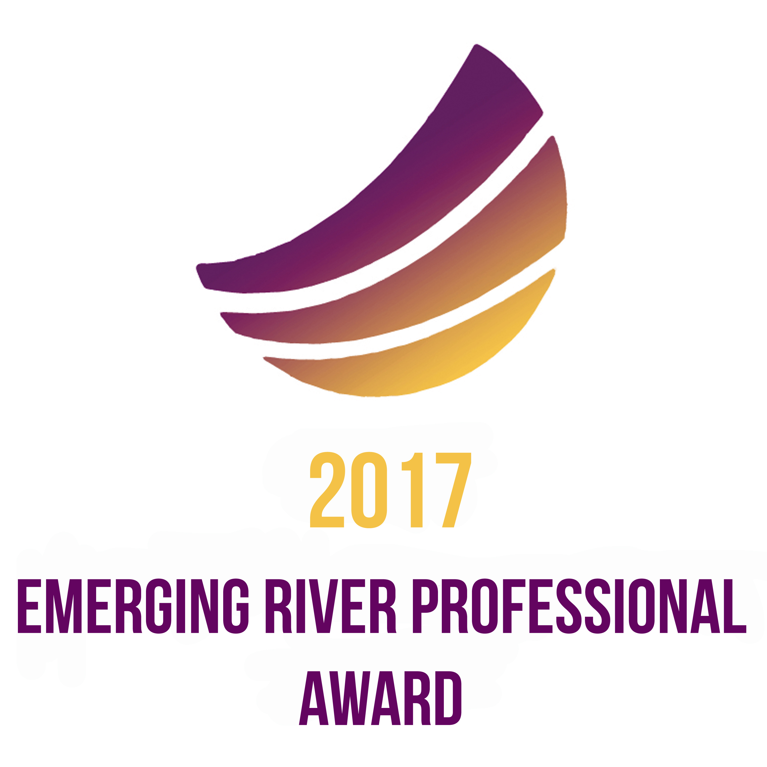

CALL FOR ENTRIES & GUIDELINES

Proudly sponsored by

PROUDLY MANAGED BY

The Emerging River Professional Award (ERPA) is an initiative of the International RiverFoundation (IRF), established to recognise and foster early career river professionals who have demonstrated innovation, excellence and leadership in river, basin, or river-dependent community management. The ERPA is generously sponsored by OceanaGold Corporation and the process is managed by the International WaterCentre Alumni Network (IWCAN).

The ERPA is open to all river professionals who have been working in their field for 10 years or less and who have demonstrated exceptional and measurable achievements in rivers, basins or river-dependent communities. Recognising the wide range of professionals that contribute to the future of our rivers, ERPA is open to professionals from all disciplines - whether scientists, policy makers or on-ground river managers. While teams are essential in all facets of river management, this award focuses on celebrating individual achievements, and rewarding hard work, dedication, innovation, and leadership. These qualities will ensure a bright future for rivers and basins globally.

Finalists will be selected through the evaluation of written submissions and oral presentations demonstrating leadership and project achievements (e.g. development of a new catchment management initiative, establishment of a new waterway group) or showcasing significant research as part of a Masters or PhD program.

ERPA finalists will be afforded the opportunity to attend the 20th International Riversymposium to be held in Brisbane, Australia from the 18th to 20th of September 2017, and present the outcomes of their work - giving a voice to our future water leaders. The winner will be announced at the Riverprize Gala Dinner on Tuesday 19 September, 2017. If you feel that you have undertaken noteworthy work in this area, or you know someone who deserves recognition for his or her achievement, consider submitting an entry for this prestigious Award. If you nominate someone else, make sure they will meet the eligibility criteria to enter (see below).

RECOGNITION AND BENEFITS

- ERPA finalists will be eligible for financial support to travel to and attend the 20th International Riversymposium in Brisbane, Australia.
- ERPA finalists will be expected to personally present the outcomes of their work as part of the International Riversymposium program.
- ERPA finalists will be recognised through the publication of project summaries on the International RiverFoundation and IWCAN websites.
- ERPA finalists will be promoted through the International RiverFoundation and IWCAN eNews channels.
- The overall winner will receive AUD $500 in prize money.
- The winner will feature in an article in the International RiverFoundation and IWCAN newsletters after the Riversymposium.

WHO CAN ENTER?

Professionals from anywhere in the world who have been working in their field for 10 years or less, and:
- can demonstrate leadership and positive outcomes, or can showcase outstanding research in a river related field;
- are available to attend and present at the 20th International Riversymposium* if selected as a finalist; and
- have completed their work (or a phase of a larger project) within the 2016 calendar year (although work could have been commenced at an earlier date).
* Please see Terms and Conditions (point 10)

HOW DO I ENTER?

- Read the Call for Entries and associated guidelines carefully to ensure the candidate’s eligibility.
- Complete the Entry Form showcasing the candidate’s leadership and initiative in the river sector.
- Email the Entry Form and associated documents to erpa@iwcan.org by COB 5 July 2017.

IMPORTANT DATES

5 July Applications close for the 2017 ERPA at 5pm Australian Eastern Standard Time
17 July Finalists announced (all candidates will be notified before public announcement is made)

FINALISTS ONLY
1 August Confirm availability to attend and present for final judging at the 20th International Riversymposium and register online. Finalists will qualify for the discounted rate for Emerging Water Professionals and will participate in the Emerging Water Professionals Program during the conference.
21 August Deadline to provide a short video to be used for marketing purposes. (Further guidelines will be provided at the time of being named a finalist.) Be prepared to respond to questions seeking project clarifications from the judges.
19 September 12 to 15 minute oral presentations during the 20th International Riversymposium
19 September Announcement of ERPA winner at the Riverprize Gala Dinner

ENTRY PROCESS AND ASSESSMENT STAGES

STAGE ONE – ENTRY AND SELECTION OF FINALISTS

Application
submission All candidates to submit a completed ERPA Entry Form including:
- Short abstract summarising the content of the work to be presented for award consideration (maximum 200 words);
- Extended summary describing candidate’s contribution or research findings (maximum four A4 pages);
- Biography (maximum one A4 page);
- Three references; and
- One jpeg image of the candidate for promotion if selected as a finalist (at a suitable quality for reproduction in newsletters and webpages).
The extended summary must:
- communicate the candidate’s work/research findings clearly, in language and style that a typical end-user will understand;
- show that the work/research reflects key objectives of delivering high-quality outcomes including:
  - show that the work/research has involved sound project management or research design, method selection and that conclusion(s) are evidence-based; and
  - show that the work/research has grown out of a comprehensive knowledge and understanding of previous work in the area; and
- demonstrate the proposal is largely the candidate’s own work, rather than part of a large team project.

Judging A panel of independent judges will select a maximum of three (3) finalists based on the candidate’s full application. Judges for the ERPA will be announced on the International RiverFoundation website and will disclose any conflicts of interest regarding the candidates prior to participating in judging activities.
Finalists The ERPA finalists are announced by email to the candidates. Candidates will be advised if they are selected as a finalist by 17 July 2017.
STAGE TWO – SELECTION OF AWARD WINNER (FINALISTS ONLY)

Short Video Each finalist will provide a short video of their work (maximum 2 to 3 minutes). This video is for promotional purposes only and will not be used in the judging process. Professional editing of the video is not required. The videos must be submitted by 19 August 2017.

Oral Presentation Each finalist will present their work at the 20th International Riversymposium as a speaker in a special session. The judges will choose the ERPA winner on the basis of these presentations and their assessment of the finalists' work/research.

Each presentation should be 12 to 15 minutes in length with an additional 5 minutes question time from the audience. The conference organisers will assign a session time for each finalist, to be advised closer to the date of the International Riversymposium. A session chair will introduce the ERPA presentations and manage the allocated presentation time for each of the finalists.

Judging After the judges attend and assess all finalists’ conference presentations, they will then confer for a final assessment based on a combination of the written submissions and conference presentations.

Winner Selection The announcement of the 2017 ERPA winner will be made at the 20th International Riversymposium Gala Dinner. ERPA runners up will also be recognised at this time. The ERPA winner may have the opportunity to present a 2-minute snapshot of their winning work following the announcement.

Every effort will be made to promote the winner’s and finalists’ successes as widely as possible. Candidates should make themselves available for possible media opportunities

JUDGING CRITERIA

Judges will base their assessment on the following criteria:

Quality Process Candidates should clearly show the planning, design and execution process in development of project/research and showcase initiatives used in the face of difficulties.
Interpretation of Results Candidates must demonstrate the outcomes of their work, its relationship to existing knowledge or practice and future implications for rivers and river basin management.
Communication Candidates must show clarity of thought within their presentation both from a written and (if a finalist) oral perspective.
Potential Impacts Candidates should highlight how their work will impact on future research and/or the practical relevance of their work.
Leadership Candidates should clearly demonstrate the leadership aspects of their work. If working as part of a team, the candidate’s role and contribution to the overall project should be clearly identified.
Innovation If possible, candidates should demonstrate how their work has been innovative in contributing to their field and to integrated river basin management.

SUBMISSION GUIDELINES

WRITTEN SUBMISSION FORMAT

Submissions must comply with the following format:
Electronic All nominations must be in electronic form and submitted using the entry form template provided
Language All entries must be written in English
General Candidates must spell out acronyms and abbreviations in the first instance
Length Extended summary content cannot exceed the four A4 page limit. This limit includes tables, diagrams, photos, references and acknowledgements. Please note that judges may not read beyond this length.
Paper size A4 (21cm x 29.5cm)
Type font Arial
Font size 10pt
Line spacing Single spacing
Compatibility Microsoft Office

TERMS AND CONDITIONS

Please note the submission of the entry form represents your understanding of the following conditions:
- Candidate must have been working in their field for 10 years or less.
- Candidate should provide 3 references supporting the work done and the candidate’s role in it.
- Nominations, supporting material and documentation remain the property of the International RiverFoundation, however the intellectual property of all projects/research remains with the candidate.
- The International RiverFoundation has the right to use submitted documentation for the purpose of marketing and public relations.
- Finalists must provide a short (2-3 minute) video about their work by 21 August 2017.
- Finalists must be available to give their oral presentation in Brisbane between 18 and 20 September 2017.
- Finalists must confirm their intention to attend the Riversymposium to present their oral presentation by 1 August 2017.
- Candidates chosen as finalists will qualify for the Emerging Water Professionals Program at the 20th International Riversymposium.
- Candidates must register online by 24 July 2017.
- If any named finalist is unable to attend, the candidate who has received the next highest score will be offered the opportunity to attend and if available, will replace the previously named finalist. This will be decided by 10 July 2017, prior to the public announcement of the finalists.
- All due items must be submitted by close of business (5pm) AEST of the due date.
- The prize money for the award is AU$500 for the winner. All finalists can request funds to support conference registration, travel to and from Brisbane, and accommodation expenses up to a maximum of AU$1500. Funding allocation will be awarded at the discretion of IRF.
  - Finalists must organise and book their own travel and accommodation associated with their mandatory attendance at the Riversymposium.
  - Should you be named a finalist and be unable to source adequate funding to attend (through assistance from your employer, institution / government, or personal funds) please contact the Riversymposium office immediately after the finalist announcement.
- Contact with any member of the judging panel prior to the announcement of the winner will render the entry invalid.
- The judges’ decision will be final and no correspondence will be entered into.
- The judging panel will draw attention to any conflict of interest they may face during the process in relation to candidates.

CONTACTS

ERPA Content & Process 20th International Riversymposium
Katharine Glanville Patricia Dalby
International WaterCentre Alumni Network International RiverFoundation
E erpa@iwcan.org E patricia@riverfoundation.org.au

EMERGING RIVER PROFESSIONAL AWARD
ENTRY FORM

CANDIDATE DETAILS
Name | Title | First |  | Last
Postal Address | Line 1
 | Line 2
 | Suburb |  | State |  | Postcode
Country
Email
Phone | Work |  | Mobile

SUBMISSION DETAILS
Entry Title | Please limit your abstract title to approximately ten (10) words  Title of presentation to be given at Riversymposium if chosen as a finalist
Abstract | Maximum 200 words, no paragraphs, no dot points, no numbering  Summary of presentation to be given at Riversymposium and may be used in media releases – if selected as a finalist you will need to send a full presentation prior to the Riversymposium

Please attach the following to your submission:
- Extended Summary (maximum 4 x A4 pages): Please describe activities and achievements. Ensure that the project/research is well described, ensure that the following has been showcased: a creative approach, relevance for the industry, methodology/project management, and demonstrate subject knowledge, practical skills, and achieved outcomes.
- 1 x A4 page biography
- 1 x jpeg image of the candidate for promotional purposes

REFERENCE ONE
Name | Title | First |  | Last
Organisation
Position
Email
Phone | Work |  | Mobile
REFERENCE TWO
Name | Title | First |  | Last
Organisation
Position
Email
Phone | Work |  | Mobile

REFERENCE THREE
Name | Title | First |  | Last
Organisation
Position
Email
Phone | Work |  | Mobile

Please ensure the candidate is eligible for the ERPA before submitting the entry:
- The candidate has completed his/her work/research in the 2016 calendar year
- The candidate has been working in his/her field for 10 years or less
- The candidate is able to attend the 20th International Riversymposium for the duration of the conference
- All information supplied is correct
- The candidate has accepted all terms and conditions outlined within the guidelines

Please email the completed Entry Form and associated documents to ERPA@iwcan.org
by 5 July 2016.

